LAB # 04

ARRAYS IN JAVA

OBJECTIVE: To understand arrays and its memory allocation.

HOME TASKS

1. Write a program that takes an array of Real numbers having size 7 and calculate the sum and mean of all the elements. Also depict the memory management of this task.

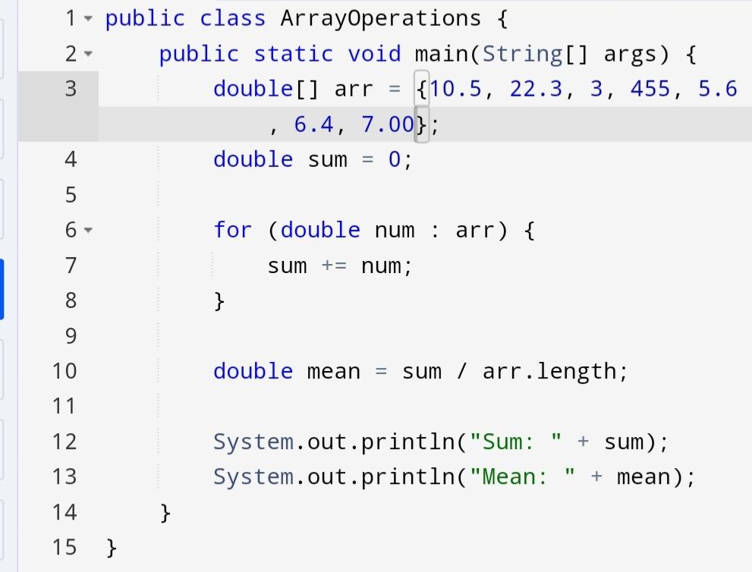Code:

Output:

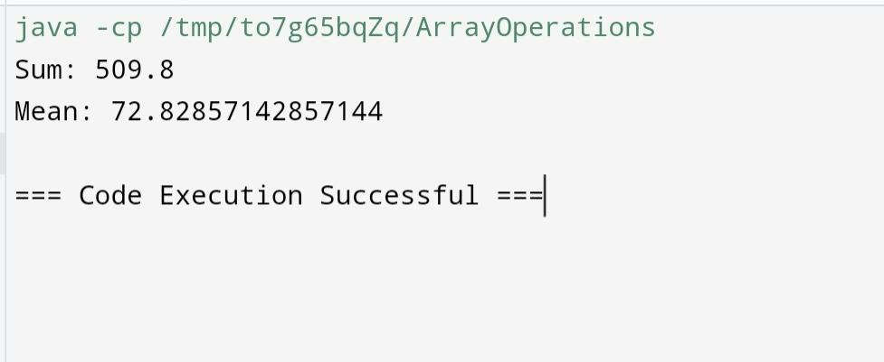

1. Add a method in the same class that splits the existing array into two. The method should search a key in array and if found splits the array from that index of the key.

Code:

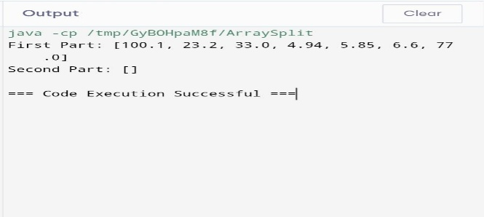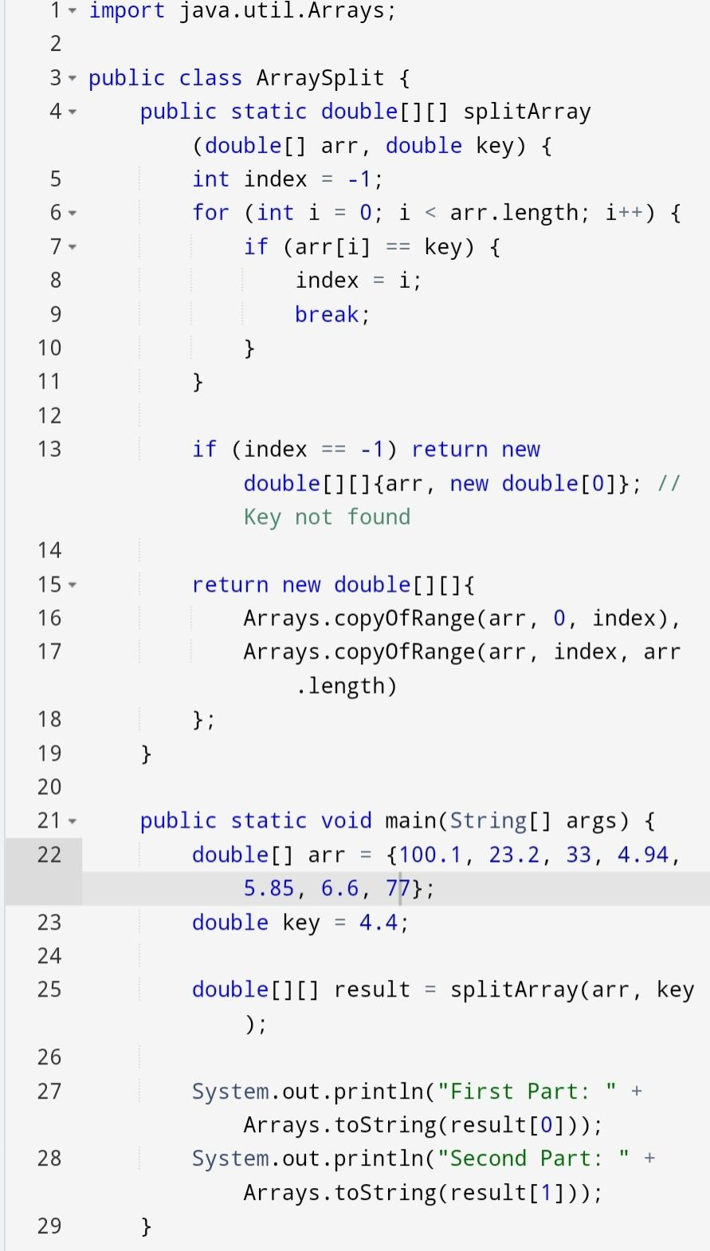

1. You are given an array containing n distinct numbers taken from 0, 1, 2, …, n. Write a program to find the one number that is missing from the array.

Code:

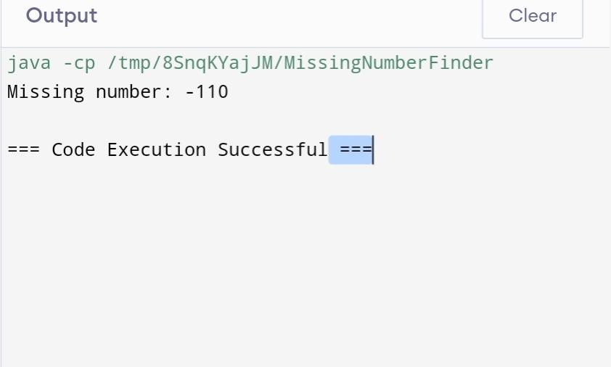Output: